Designing Interactive Transparent Exhibition Cases

1st Author

1st author's affiliation  
1st line of address  
2nd line of address  
Telephone number, incl. country code

1st author's E-mail address2nd Author

2nd author's affiliation  
1st line of address  
2nd line of address  
Telephone number, incl. country code

2nd E-mail3rd Author

3rd author's affiliation  
1st line of address  
2nd line of address  
Telephone number, incl. country code

3rd E-mail

**ABSTRACT**

Interactive technologies in museums and galleries enhance on-site learning by providing information and motivating collaboration and participation. In this paper we revisit the design of an existing exhibition medium – the transparent case – from a museum learning perspective. Transparent cases with interactive properties can complement other museum technologies and minimize their shortcomings (e.g. mobile devices isolate groups; public displays are disconnected from the objects). This paper focuses on the design of interactive cases and makes three contributions. First, based on field observations and interviews we present a list of requirements for interactive cases. Second, we propose a design space with dimensions grouped around the themes of *hardware*, *interaction* and *information* design. Our design space suggests interactive cases which show collocated information at increasing levels of detail, support different input modalities, facilitate social interaction and integrate with other technologies. Third, we demonstrate our design space by presenting sample case designs and discuss the general technical challenges they pose.

**Categories and Subject Descriptors**

H5.2 [Information interfaces and presentation]: User Interfaces. - Graphical user interfaces.

**General Terms**

Design, Human Factors.

**Keywords**

Transparent Displays, Cultural Heritage, tCase, Exhibition, Transparent Case, Case Display, Museum Display

# INTRODUCTION

The museum visiting experience is evolving due to the emergence of novel interactive technologies [5]. Technologies such as audio guides, mobile applications and public displays allow museum visitors to access relevant information on-site, to personalize this information, and to collaborate with other visitors. These novel information and interaction opportunities redefine the traditional roles of museums; from institutions that deliver formal learning, to spaces that facilitate open-ended explorations and alternative interpretations of art and history [5].

Sharples [14] enumerated a set of goals for effective museum technologies (e.g. portability, unobtrusiveness, intuitiveness). However, field deployments show that current technologies, although fulfilling most of these design goals, present undesirable side effects. For example, audio guides isolate people from the group hindering collaborative explorations. Mobile applications take the attention away from the exhibition to the device. Public displays are spatially detached from the objects they augment and occupy space which could be dedicated to more artifacts.

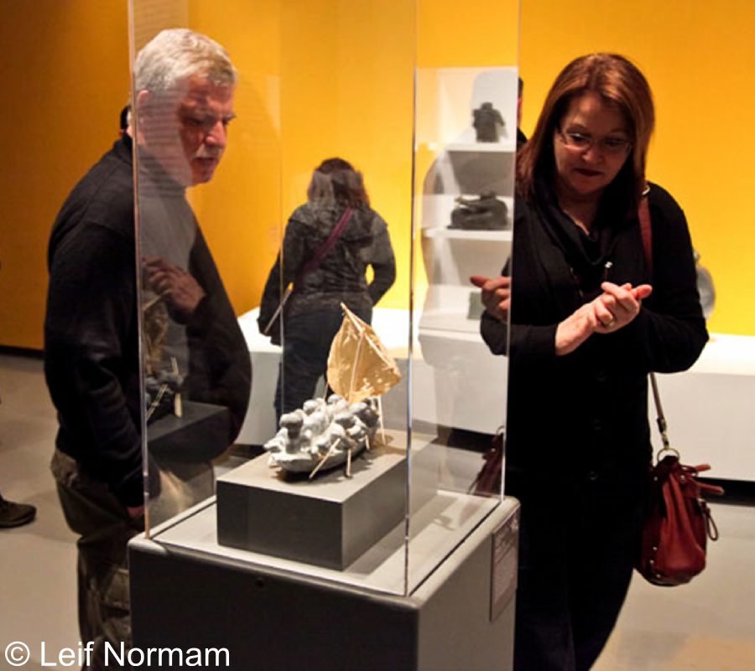

Figure 1: Traditional acrylic exhibition case (non-interactive).

Recent advances in transparent display technologies allow us to envision their usage alongside other museum technologies, particularly if embedded in exhibition cases. Exhibition cases are essential media for the showcase of volumetric artifacts which, unlike pictograms, should be explored from multiple angles (see Figure 1). The glass/acrylic helps protect the artefact from visitors and environmental conditions. Attached labels provide basic information for the visitor. Augmenting exhibition cases with interactive capabilities can offer the necessary multi-angle exploration and protection while providing richer information and interactions. Used alongside other museum technologies, interactive cases can make information available where and when it is needed, reach a wider public, and foster group dynamics.

Permission to make digital or hard copies of all or part of this work for personal or classroom use is granted without fee provided that copies are not made or distributed for profit or commercial advantage and that copies bear this notice and the full citation on the first page. To copy otherwise, or republish, to post on servers or to redistribute to lists, requires prior specific permission and/or a fee.

*Conference’10*, Month 1–2, 2010, City, State, Country.

Copyright 2010 ACM 1-58113-000-0/00/0010 …$15.00.

In this paper we explore the design challenges and opportunities involved in transforming exhibition cases into interactive media. First, we performed field observations in museums and galleries, and conducted interviews with relevant stakeholders. Based on our fieldwork we present a set of requirements for interactive cases which include support for multi-side exploration, information scaffolding and open-ended exploration. Further, based on our own and others’ experiences designing museum and public display technologies we propose a design space for interactive cases, and group its dimensions along the themes of *hardware*, *interaction* and *information* design. This design space highlights different possibilities for the design of interactive cases which meet the mentioned requirements. Finally, we use our design space to design sample cases and discuss some of the technical challenges involved in their implementation.

# RELATED WORK

The arrival of tape recorded tours [14] and the Internet [5] marked the beginning of a new era in our relationship with museums where information technologies complement the traditional ways of obtaining information about the exhibits such as books, exhibition booklets and expert guides. Over the years, other technologies have been introduced with ever more promising results [5]. Digital audio guides allow visitors to navigate the audio contents interactively and in a non-sequential manner [12]. Mobile devices bring multi-media content to the hands of the visitor. Head-worn displays provide context-sensitive information based on user’s location and gaze. Public displays foster group engagement and collaboration.

As technologies evolve, the *raison d'etre* of museum technologies has changed. Starting from an initial focus on information access and online publishing, new developments focus on interactive experiences, personalization and collaborative exploration. Sharples [14] generalizes from many experiences and argues that effective interactive technologies for museums should be portable, individual, unobtrusive, available anywhere, adaptable to learning, persistent, useful and intuitive. Besides the mentioned mobile devices and public displays, researchers have started to look into augmented reality (AR) as an interaction paradigm that could fulfill most of these goals. Mobile augmented reality, as used in [1], augments objects by simply pointing a handheld device at them. Spatial AR [2] uses fixed displays and projectors to augment objects. Although not mobile, spatial AR provides higher visual definition which can be shared among visitors.

In this paper we depart from existing approaches to museum technologies, and investigate the re-design of an existing media. To the best of our knowledge, this work is the first to study exhibition cases as information appliances for museums. By redesigning existing exhibition cases, we expect to lower the entry barrier for visitors and, given their public nature, leverage their potential for social interaction. We go beyond proposing exhibition cases as devices for spatial AR (this is an alternative to the *content alignment* dimension ofour design space) and discuss issues such as *attention attraction* and *personalization*.

# ARTIFACTS ON DISPLAY

In order to understand the design and usage of transparent cases we conducted field observations at the [XXX] Museum and the [YYY] Art Gallery. We analyzed the location, orientation and physical layout of exhibition cases, and performed artefact-centered observations of visits. We captured our observations in pictures, and later tagged them and aggregated the tags into general themes. We also interviewed museum personnel including two curators and two admin workers involved in their installation and maintenance. This section presents the results of our fieldwork and interviews as requirements for interactive cases; implicit is requirement to protect and safeguard the exhibit.

The first requirement for an interactive transparent exhibition case is *to support exploration from as many angles as needed* by the artefact (**R1**). For example, Figure 2A shows a case for simple objects which are “enough” to see from one side. On the contrary, Figure 1 and Figure 2B show cases where the objects are rich in details from multiple sides. The required number of transparent sides and the size of the object influence the location of the case. Single side cases are easily located against a wall (Figure 2A). Small all-around cases like in Figure 1 can be in the middle of a room in order to allow all around exploration. Bigger cases can be near walls and even separate different rooms (Figure 2B).

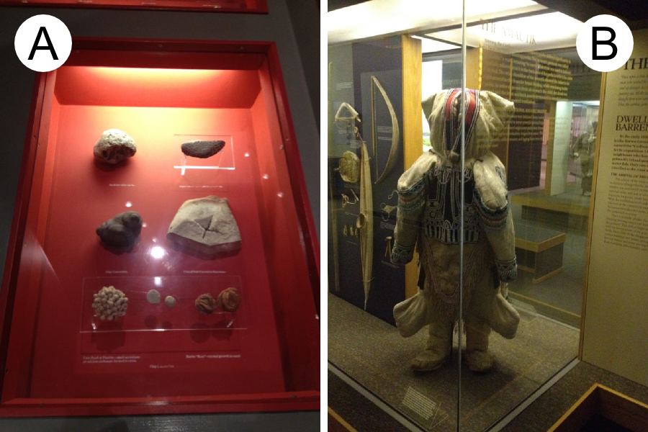

Figure 2: Planar and all-around transparent cases.

The second requirement is *to link information to objects in accessible ways* (**R2**). Exhibition space is scarce and curators optimize it by grouping several objects in a single case (Figure 2A), and balancing the number of objects and information detail. This tension is often resolved by using small labels which limit the amount of information and affect its readability. More information is provided in the exhibition hand-outs or the didactic panels (Figure 2B-wall), however these elements are separated from the exhibit and could be ignored (display blindness).

The third requirement, inspired by [14], is *to present information in unobtrusive and intuitive ways* (**R3**). Museums receive a wide range of visitors ranging from school pupils to older adults. Therefore, information should be provided in an accessible way for all audiences. This is evident in the current utilization of small labels and side panels which, as highlighted by admin personnel, present a low entry barrier for the less tech-savvy visitors.

The fourth requirement is *to facilitate information scaffolding* around the notion of interpretation *layers* (**R4**). Interpretation layers connect the objects of an exhibition. One layer might be the thesis the exhibition presents and connects all of its objects (e.g. the oral tradition of a tribal group). Another layer might be the works by a particular artist or material. The latter types of layers connect only a subset of the objects within the collection. Layers might also reach beyond the local collection. While some of the visitors might not be interested in any of the layers (e.g. tourists), others might be interested on the general thesis and more specialized visitors might follow particular layers (e.g. an artist). Moreover, making layers explicit provides context for the whole collection, even if other cases are not interactive.

The fifth requirement is *to support collaborative interaction* (**R5**). Transparent cases, similar to public displays, allow visitors to concentrate on an artefact and share interpretations. In a formal setting visitors stand around the case and a guide indicates the points of interest of a given object. Informal groups stand around the case, explore and pointing at the artefact freely, changing positions and collaboratively sharing interpretations.

The final requirement is *to enable open-ended explorations* (**R6**). The static nature of exhibition environments supports a learning experience where curators provide interpretations of the works (through static media such as fliers, labels and panels). Novel technologies should support museum visitors in creating and sharing alternative interpretations.

# DESIGNING INTERACTIVE CASES

Designing interactive cases to meet the outlined requirements can take many shapes. Moreover, previous works on museum [5] and public display [9] technologies suggest important design problems which cannot be observed in with non-interactive cases (e.g. attracting attention and motivating interaction). In this section we propose a design space for interactive cases (see Figure 3) aimed at meeting the requirements presented in the previous section and the challenges listed in the literature. We group the design space dimensions around three themes: *hardware*, *interaction* and *information* design.

## Hardware Design

These dimensions define the physical design of the case. For the sake of completeness hardware design also covers the provision of security, protection and environmental conditions [16].

*Transparent Display Technology* – Transparent see-through displays can be additive (e.g. projector-based or T-OLED) or subtractive (e.g. LCD). Projector-based displays use diffusive films or half mirrors, providing high levels of transparency, but requiring space for locating the projector. T-OLED displays are self-contained, but are the least transparent and have low color capacity [15]. LCD displays require a backlight and offer medium transparency; their usage should be limited to artefacts which can resist bright illumination. Selecting a display technology should consider the space availability, required transparency (**R3**) and light resistance of the exhibit.

*Display Coverage* – This dimension refers to the percentage of the transparent surface which is a digital display. Given that displays cannot yet be made fully transparent, they blur objects. Moreover, interactive displays are often “owned” by the active user, creating the honey pot effect [9] and keeping others from coming closer and exploring the object. In the case of single-sided cases (Figure 2A) proximity can minimize blurring. For larger displays and more sides, limited display coverage provides fully transparent areas for clear and people-free exploration (**R1**, **R3, R5**).

*Input Mechanism* – Depth cameras support natural (gestures, gaze tracking, virtual arms) or touch interfaces depending on their placement (front facing or parallel to the display respectively). IR cameras inside the box can support touch by means of FTIR or DI [13]. Camera-based and capacitive touch frames attach to the display requiring little space. Tangibles can serve as interaction surrogates to “select” content [6]. Finally, traditional input (e.g. keyboard, mouse, touchpads, trackballs, etc.) can support longer interactions and the less tech-savvy visitors (**R3**).

## Interaction Design

These dimensions define visual aspects of the interaction.

*Content Alignment* – The digital content showed by the display can be *aligned* or *plain*. *Aligned* content maintains a fixed real-world location from the user perspective (see spatial AR [1]). Aligned content changes its pixel location according to the relative locations of the user, the display and the exhibit. Although aligned content can optimize information linking (**R2, R3**), the content looks correctly aligned to only one observer at the time. *Plain* content maintains a fixed pixel location independent of the user location making it easy to read from multiple angles (**R1**) and people (**R5**) simultaneously.

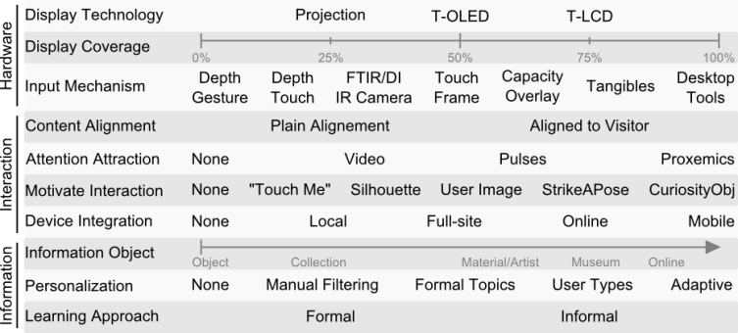

Figure 3: Design space for interactive exhibition cases.

*Visitor Attraction* – Researchers showed that users often ignore the digital nature of displays in public spaces [9]. We expect this to be a problem also for interactive cases as users expect a non-interactive experience. Saliency (sudden changes in color or motion) captures users’ attention as it triggers our instinctive defense reflexes. Video content (similar to screensavers) and random pulsations (to color, to black, to transparent) can run until a visitor touches the display or is detected by a tracking system. Proxemics can be used to estimate the visitors’ attention and adapt content accordingly [18]. See Müller et al. [9] for a larger discussion of attention in public displays.

*Communicate and Motivate Interaction* – Public displays are often expected to be non-interactive, a phenomenon called interaction blindness [11]. A simple solution is to invite visitors to interact via “touch me”-type of messages. More elaborate solutions include displaying the users’ silhouette and image [10], prompting users to “strike a pose” [17], or using “curiosity objects” [7]. Some of these methods also support open-ended interaction (e.g. playfulness of curiosity objects - **R6**). In any case, their design should be unobtrusive should the visitor not want to interact (**R3**).

*Device Integration* – Interactive cases can operate as isolated devices (*solo*), but this limits their capacity to provide, for example, portability. Alternatively, interactive cases can integrate with devices in the same room (*local*), with devices all over the museum (*full-site*), and with online visitors and content (*online* – see [RE]). Another option is to integrate with the visitor’s *mobile* devices and support interactions such as overview/details (**R4**) or content sharing and group coordination (**R5**).

## Information Design

These dimensions define what information is shown by the case.

*Information Object* – Interactive cases can provide information only about the exhibit or can extend its reach to inform about other objects in the exhibition, other collections, the institution, etc. Information can be provided along the information layers of an exhibit, by relating objects in the same layer (**R4**) or contrasting objects in different ones. How far a visitor can explore information layers impacts the storage architecture. For example, when exploring artefacts by the same artist, the interactive case can pull such information from the museum’s website.

*Personalization* – Personalization is an important aspect of museum technologies as it tailors the information to the visitor, providing the depth or breadth they expect. Interactive cases might present a single navigation path with standard information. Another option is to enable open exploration (manual filtering) by allowing users to click/activate content on demand (**R4**, **R6**). Others have proposed the classification of users and content into predefined types. Such classification could be automatic, or started manually by the user or the visit host. Finally, adaptive user models can learn from past visitors to classify future ones and adjust content.

*Learning Approach* – The interactive case can be designed to support *formal* or *informal* learning processes. Formal learning is one-way, where curators create content (interpretation) and guide users through its exploration. On the other side, support for informal learning allows users to freely explore and relate the information available in order to create and share alternative interpretations of the artefacts (**R6**).

# DESIGN EXPLORATION

Our ongoing work is the design of an interactive transparent exhibition case for the [XXX] Art Gallery in their [AAA] art collection. We demonstrate our design space by designing sample interactive cases for a small sculpture (similar to Figure 1). Based on these samples we discuss general implementation challenges.

Figure 4A shows a sample design based on a wooden top, a cylindrical acrylic surface and a top rotating unit made up by a short-throw projector, a top projector, and an infrared-camera. The acrylic surface rests on an infrared LEDs light strip embedded in the wooden top. Two areas of the acrylic surface are covered with a semi-transparent diffusive film (20% of the surface each). A transparent display is created by the short-throw projector on the film-covered areas. Proximity sensors on the side of the wooden top detect nearby users. When there are no users the top projector creates ambient animations. When a visitor comes to an interactive area the system rotates the top unit so that the short-throw projector creates a transparent display for the visitor with a non-aligned content. The visitor interacts with the contents via touch (FTIR with the infrared light strip and camera). Icons indicate the possibility to explore a topic (touch-me motivation, manual filtering). For example, touching the artist name shows a picture, biography and other works in the room (the information object is the actual room). When a display is being used, the top projector provides other visitors with small labels on the wooden top. This sample design does not integrate with other devices.



Figure 4: Design space for interactive exhibition cases.

Figure 4B shows a sample single-sided interactive case embedded into a wall. The system uses a transparent LCD on the complete transparent side and a depth sensor for skeleton and gaze tracking. A touch-enabled 3D-printed replica of the sculpture is place in front of the display. With no visitors, ambient animation is overlaid on the exhibit. Visitors are attacked by the ambient visualization or the 3D-printed replica (as a curiosity object). When the skeleton tracking system detects a visitor the system displays basic information aligned according the gaze tracking information. Visitors obtain more information by touching parts of the 3D-printed replica (manual filtering). A mobile application allows users to public hand drawings to the case for a limited time (ephemeral graffiti) for informal and open-ended explorations.

Implementing these two designs poses interesting technical challenges. The following are examples that illustrate the complexity of the implementation. First, the short projection distance of the cylindrical case requires key-stoning and image warping. While key-stoning is already present in some projectors, cylindrical image warping should be added to the graphics pipeline. Second, calibration is needed for FTIR touch on a cylindrical display, and for location tracking (gaze and skeleton) in relation to the display and the object. Finally, binocular parallax affects visualizations and requires novel cursors [8] and highlighting components.

# CONCLUSIONS

The emergence of transparent display technologies shows promise for the re-design of existing museum media as information appliances to support the museum learning experience. This paper presents a set of requirements for designing interactive transparent exhibition cases. Based on these requirements, on reported experiences in the museum and public display literature, and on our ongoing design efforts, we present a design space definition for interactive cases. Our design space shows that designing interactive cases goes beyond *hardware* issues, to include aspects such *interaction* and *information* design. Finally, we present sample case designs and discuss their implementation challenges.

# REFERENCES

1. ArtLens, Cleveland Museum Art. 2013. [Website] <http://www.clevelandart.org/gallery-one/artlens>
2. Bimber, O., Raskar, R., & Inami, M. 2005. Spatial augmented reality. Wellesley: AK Peters.
3. Brignull, H., & Rogers, Y. 2003. Enticing people to interact with large public displays in public spaces. In Proc. of INTERACT 2003.
4. Galligan, A. M. 1996. Tape recorded tours and the museum-going experience. The Journal of Arts Management, Law, and Society, 26(1), 7-15.
5. Hawkey, R. 2004. Learning with digital technologies in museums, science centres and galleries.
6. Hincapié-Ramos, J. D., Esbensen, M., and Kogutowska, M. 2011. Rapid Prototyping of Tangibles with a Capacitive Mouse. In Proc. DHRS2011.
7. Houben S. and Weichel, C. 2013. Overcoming interaction blindness through curiosity objects. In CHI EA '13. ACM.
8. Lee, J.H. and Bae, S.H. 2013. Binocular cursor: enabling selection on transparent displays troubled by binocular parallax. In Proc. CHI '13. ACM.
9. Müller, J., Alt, F., Michelis, D., and Schmidt, A. 2010. Requirements and design space for interactive public displays. In Proc. MM'10. ACM.
10. Müller, J., Walter, R., Bailly, G., Nischt, M., & Alt, F. 2012. Looking glass: a field study on noticing interactivity of a shop window. In Proc. CHI '12. ACM.
11. Ojala, T., and Kostakos, V. 2012. Multipurpose interactive public displays in the wild: Three years later. Computer.
12. Proctor, N., & Tellis, C. 2003. The State of the Art in Museum Handhelds in 2003.
13. Schöning, J., Hook, J., Bartindale, T., Schmidt, D., Oliver, P., Echtler, F., Motamedi, N., Brandl, P., and von Zadow, U. 2010. Building interactive multi-touch surfaces. In Tabletops-Horizontal Interactive Displays. Springer London.
14. Sharples, M. (2000). The design of personal mobile tech-nologies for lifelong learning. Computers&Education, 34 (3).
15. Sridharan, S.K., Hincapié-Ramos, J.D., Flatla, D., and Irani, P. 2013. Color correction for optical see-through displays using display color profiles. In Proc. VRST '13. ACM.
16. Thomson, G. (1977). Stabilization of RH in exhibition cases: Hygrometric half-time. Studies in Conservation.
17. Walter, R., Bailly, G., & Müller, J. 2013. StrikeAPose: revealing mid-air gestures on public displays. In Proc. CHI'13. ACM.
18. Wang, M., Boring, S., and Greenberg, S. 2012. Proxemic peddler: a public advertising display that captures and preserves the attention of a passerby. In Proc. Pervasive Displays 2012. ACM.

Columns on Last Page Should Be Made As Close As Possible to Equal Length